Report for Embedded System Coursework

# Instructions

## Start Screen

When starting the program up, you are greeted with a start screen.

-Press ‘DOWN’ to continue the last saved game --- Goes to MAIN MENU.

-Press ‘RIGHT’ to start a new game --- Goes to MAIN MENU.

## Main Menu

-Press ‘UP’ to continue/start the game --- Goes to the GAME SCREEN.

-Press ‘LEFT’ to exit to the start screen, this saves your game --- Goes to the START SCREEN.

## Game Screen

-Press ‘LEFT’ to feed your pet – Increases food by 1.

-Press ‘RIGHT’ to play with your pet --- Increases happy by 1.

-Press ‘DOWN’ to pause and go to the main menu --- Goes to the MAIN MENU.

-Press ‘UP’ to grow your pet --- increases devStage from 1 to 2.

## Game Over Screen

Once age reaches 600, you’ll be taken to the game over screen, this means your pet has grown old and passed on. This will reset any progress, continuing will make a new game.

-Press ‘UP’ as shown on screen to return to the start screen --- Goes to START SCREEN.

## Rules

1. Your animal is an egg until age = 5, which it then becomes young (Dev = 1). Whilst in egg form, you cannot feed or play with them. As an egg, only **this** rule applies.
2. Every 7 seconds, your animal’s fullness is reduced by 1 (minimum of 0).
3. Every 11 seconds, your animal’s happiness is reduced by 1 (minimum of 0).
4. You can only play with your animal if their food is above or equal to 2.
5. If you overfeed your animal (food = 4) they will get unhappy (happy = 0).
6. Your animal will only get to an adult (dev = 2) when ‘UP’ is pressed when:

* Age is greater than or equal to 35.
* Food is greater than or equal to 3.
* Happiness is great than or equal to 1.

1. When your animal reaches age of 600, it will pass on and the game will end.

## Notes on the videos:

-VideoOne shows most of the features all in one go. It does **not** show the passing of the pet or showing the additional timing feature to stop the exploit.

-VideoTwo shows the passing of the creature and what happens.

-VideoThree shows the timing feature I added to stop an exploit, more info shown below.

# Features

-Depending on what is selected at start screen, it will load from the EEPROM straight away, or will reset the current then load that.

-On the main menu the user can press a button to get into the game or return to the start screen, returning the start screen saves the current game into the EEPROM.

-At any point, the player can **pause** the simulation and return to the main menu by pressing ‘DOWN’.

-The pet has 4 stats; development stage, happiness, fullness and age.

-When starting a new game these are defaulted to: 0, 3, 2, 0, respectively.

-Age increases per second, this is only when the user is not in the main menu or start screen, then the simulation is paused.

-At dev stage 0 the pet is an egg. Once age reaches 5 (5 seconds), then the egg hatches and dev stage becomes 1.

-When the development stage >= 1 ,the current stats are displayed on the LCD screen.

-When dev stage = 1, the pet’s fullness and happiness decrease, every 11 and 7 seconds respectively. Their values cannot drop below 0.

-Additionally when dev stage >= 1, then the user can either play, feed or grow their pet.

-Playing with the pet by pressing ‘RIGHT’ requires the pet to have at least 2 in fullness, if so then the happiness increases by 1, not exceeding 3.

-Feeding your pet by pressing ‘LEFT’, increases their fullness by 1, to a maximum of 4. If the pet reaches 4 fullness then it is considered overfed, and their happiness reduces to 0.

-When age reaches 35 (35 seconds) , and the pet’s happiness >=1 and fullness >= 3, then the ‘UP’ button is pressed, the development stage is increased to 2.

-When the pet’s age reaches 600 (10 mins), the per grows old and passes. This marks game over and the data is removed, trying to continue the game will just be a new game.

## Omitted Features

-I did **not** add functionality to delete the current pet without having to start a new game or reaching the end of the current game. This is because if someone was to delete a game I assumed they would want to start another one in its place.

-No feature to quit the game entirely, this would require the power to turn off, which is something you cannot do with a command.

## Additional Features

-I added a feature that when the user is in the menu the current time between decreasing the values is saved, so if the user was 3 seconds into the 7 seconds reducing happiness time, then when the user exits the menu, it will only wait 4 seconds to reduce the happiness, this also works for fullness. This gets rid of an exploit to constantly go in and out of the menu to never reduce the happiness and hunger. (VideoThree)

-I split up the functionality of the main menu into a start screen and a menu, where the start screen is where you manipulate the game saves, and the menu is just basically a pause screen for the game where you can continue or save and exit.

# Flow Charts / Finite State Machine Diagrams

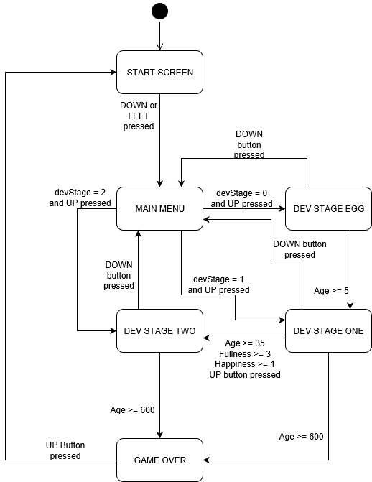

You can see in the diagram all the steps to get from each of the states to one another. Age, fullness, happiness and devStage are all attributes of the pet.

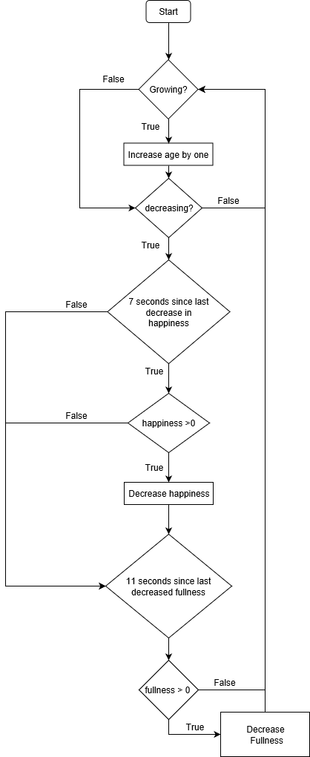

Here you see the main decreasing algorithm, it only runs when the simulation isn’t paused (growing and decreasing are 0 when paused). When the simulation is growing (devStage >= 0) then the age increases per second. It then checks to see if the values are meant to be decreasing (devStage >= 1), if so it checks if the elapsed times have occurred, if they have then the attributes are decreased.